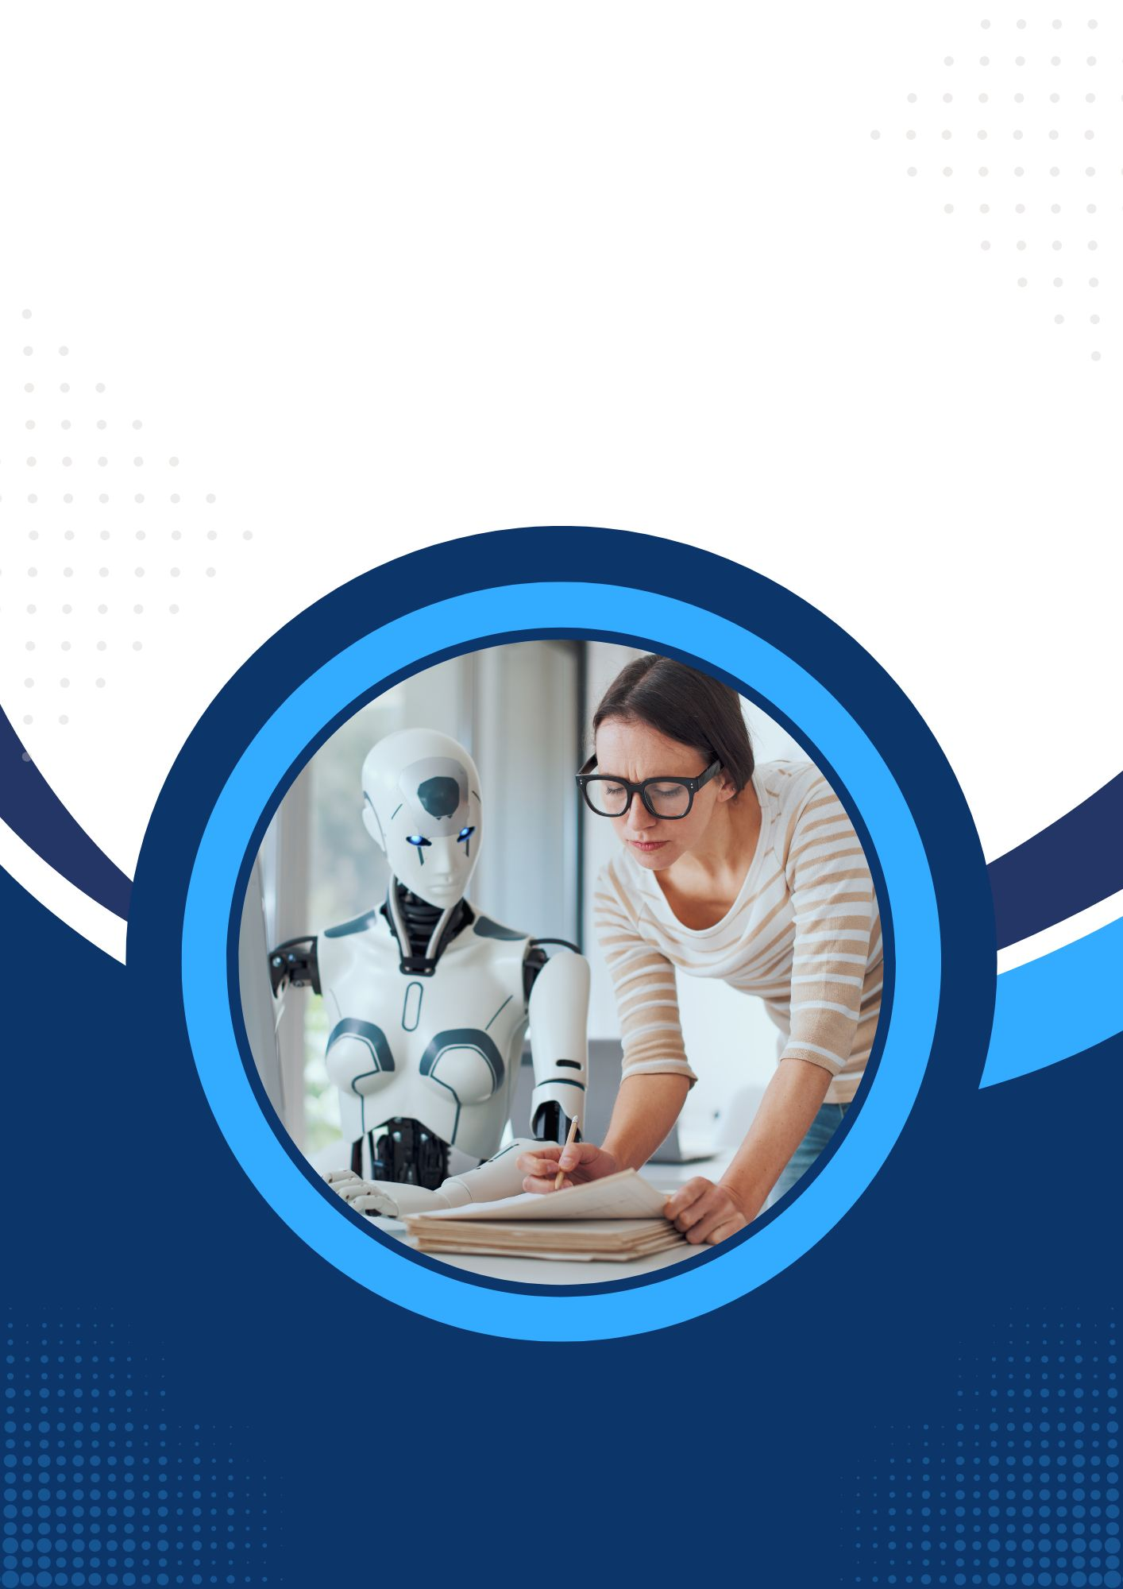
/*
AI CAREER FOR WOMEN
Science

Ai – resume match
A Project Report
Submitted in partial fulfillment of the requirements
of
AICW project.

By

Khushi Srivastava,
khushisrivastava442@gmail.com
Kirti gupta,
Kirtigupta12346@gmail.com
Khushi Verma,
khushive246@gmail.com
Pinki rajak,
pinkirajak523@gmail.com

Under the Guidance of
Sir, Vedant saraf

ACKNOWLEDGEMENT
We would like to express our sincere gratitude to everyone who supported us during the completion of this project.
Firstly, we would like to thank our project supervisor, sir,vedant saraf,, for his valuable guidance, encouragement, and continuous support throughout this project. His advice, suggestions, and motivation played an important role in the successful completion of our work. His mentorship not only helped us in this project but also improved our knowledge and professional understanding.
We would also like to thank our teachers, friends, and family members for their constant support, encouragement, and motivation.
Finally, we extend our heartfelt thanks to everyone who contributed directly or indirectly to the successful completion of this project.
Thank You.

ABSTRACT of the Project

Finding suitable jobs and internships is difficult for students and fresher’s, as many apply without knowing whether their skills match job requirements. AI Resume Match is designed to solve this problem through resume analysis and smart recommendations.
The main objective of the project is to analyse resumes based on skills, education, and experience and suggest relevant jobs and internships. It also helps users track their applications easily.
The system extracts key information from resumes and compares it with job requirements using AI-based matching techniques. Based on this analysis, users receive personalized recommendations.
The project improves job matching accuracy, saves time in job searching, and helps users make better career decisions. In conclusion, AI Resume Match provides an efficient and user-friendly solution for connecting candidates with suitable opportunities.

TABLE OF CONTENTS
Abstract
List of Figures
List of Tables

Chapter 1. Introduction
1.1 Problem Statement
1.2 Motivation
1.3 Objectives
1.4. Scope of the Project
Chapter 2. Literature Survey
Chapter 3. Proposed Methodology
Chapter 4. Implementation and Results
Chapter 5. Discussion and Conclusion
References

LIST OF FIGURES
Page No.

LIST OF TABLES
Page No.

CHAPTER 1

1. Introduction

1.1 Problem Statement
Finding suitable jobs and internships is a major challenge for students and fresher’s. Many candidates apply for opportunities without understanding whether their skills, education, and experience match the job requirements. This leads to wasted time, irrelevant applications, and lower chances of selection. Therefore, a smart system is needed to analyze resumes and provide relevant job and internship recommendations.

1.2 Motivation
This project was chosen to make the job search process easier and smarter for students and fresher’s. With increasing competition, candidates need proper guidance to find opportunities that match their profiles. The system can be useful for students, fresh graduates, and job seekers by helping them discover suitable jobs and internships. It can improve career planning, save time, and support better recruitment decisions.

1.3 Objective
The main objectives of this project are:
- To analyze resumes based on skills, education, and experience.
- To suggest relevant jobs and internships to users.
- To provide personalized recommendations using AI-based matching.
- To help users track and manage applications efficiently.
- To simplify and improve the job search process.

1.4 Scope of the Project
The project focuses on resume analysis and job recommendation for students and fresher’s. It matches user profiles with available jobs and internships based on relevant information. The system includes resume analysis, recommendation, and application tracking features.
Limitations:
- Recommendations depend on the accuracy of resume data.
- The system may not cover all job platforms or industries.
- Advanced AI prediction and real-time recruitment integration are outside the current scope.
.

CHAPTER 2

2. Literature Survey

2.1 Review of Relevant Literature / Previous Work
Many online job portals and recruitment platforms provide job and internship recommendations to users. Existing systems mainly use resume screening, keyword matching, and profile analysis to connect candidates with suitable opportunities. Several studies and platforms have shown that AI and machine learning can improve the recruitment process by analyzing resumes and matching candidates with job requirements.

2.2 Existing Models, Techniques, and Methodologies
Different techniques are used in job recommendation systems, such as:
- Keyword Matching: Comparing resume keywords with job descriptions.
- Resume Parsing: Extracting information like skills, education, and experience from resumes.
- AI/ML-Based Recommendation Systems: Using algorithms to provide personalized job suggestions.
- Profile Matching Techniques: Comparing candidate profiles with job requirements to measure compatibility.
These methods help automate recruitment and reduce manual screening efforts.

2.3 Gaps, Limitations, and Proposed Solution
Existing systems often provide generic recommendations and may not accurately analyze a candidate’s complete profile. Many platforms focus mainly on keyword matching, which can ignore important factors like education, skill relevance, and experience level. Some systems also lack features for application tracking and personalized guidance.
The proposed AI Resume Match project addresses these limitations by analyzing resumes in a more structured way using skills, education, and experience. It provides personalized job and internship recommendations and includes an application tracking feature to help users manage their job search efficiently. This makes the system more useful, accurate, and user-friendly for students and fresher’s.

CHAPTER 3

3. Proposed Methodology

3.1 System Design
The AI Resume Match system is designed to analyze user resumes and recommend suitable jobs and internships. The system works by collecting user details, analyzing resume data, matching profiles with job requirements, and providing recommendations.

3.1.1 Registration
Users create an account by providing details such as name, email, password, education, skills, and resume upload. After successful registration, users can access the platform features.

3.1.2 Resume Analysis & Recommendation
The system analyzes the uploaded resume and extracts important information such as skills, education, and experience. This information is compared with job and internship requirements to generate personalized recommendations.

3.2 Modules Used

3.2.1 Resume Analysis Module
This module extracts data from the uploaded resume, including skills, education, and work experience.

3.2.2 Job Recommendation Module
This module matches the user profile with available jobs and internships using AI-based matching techniques.

3.2.3 Application Tracking Module
This module helps users monitor and manage the status of their job and internship applications.

3.3 Data Flow Diagram (DFD)
A Data Flow Diagram (DFD) represents the flow of information in the AI Resume Match system. It shows how data moves between users, processes, and the database.

3.3.1 DFD Level 0
User → AI Resume Match System → Database
- User registers/login to the system.
- User uploads resume details.
- System analyzes resume data.
- System provides job and internship recommendations.
- Application details are stored in the database.

3.3.2 DFD Level 1 – User Registration Module
- User enters registration details.
- System validates information.
- User account is created and stored in the database.

3.3.3 DFD Level 1 – Resume Analysis Module
- User uploads resume.
- System extracts skills, education, and experience.
- Data is processed and saved for matching.

3.3.4 DFD Level 1 – Job Recommendation Module
- System compares user profile with job requirements.
- Matching process generates recommendations.
- Recommended jobs/internships are displayed to the user.
- Users can track applications through the system.
.

3.1 Advantages
- Provides personalized job and internship recommendations.
- Analyzes resumes based on skills, education, and experience.
- Saves time by reducing manual job searching.
- Helps students and fresher’s find suitable opportunities easily.
- Includes application tracking for better management.
- Improves job matching accuracy using AI-based techniques.
- User-friendly and easy to access.

3.2 Requirement Specification

3.2.1 Hardware Requirements:
- Processor: Intel Core i3 / i5 or higher
- RAM: 4 GB minimum (8 GB recommended)
- Storage: 50 GB free disk space
- System Type: 64-bit Computer/Laptop
- Internet Connection: Required for online access and data processing

Software Requirements:
- Operating System: Windows 10/11, Linux, or macOS
- Frontend: React.js, HTML, CSS, JavaScript
- Backend: Node.js, Express.js
- Database: MongoDB Atlas / MongoDB
- Code Editor: VS Code
- Browser: Google Chrome / Microsoft Edge
- Version Control: Git & GitHub (optional)

CHAPTER 4

4. Implementation and Result

4.1 Results of Resume Analysis
This module analyzes the uploaded resume and extracts important information such as skills, education, experience, and qualifications. The system successfully processes resume data and organizes it for further matching.

4.2 Results of Job & Internship Recommendation
After analyzing the resume, the system compares user profiles with available job and internship requirements. Based on matching criteria, the system provides personalized recommendations suitable to the user’s skills and qualifications.

4.3 Results of Application Tracking
The application tracking module allows users to view, manage, and monitor their applied jobs and internships. Users can track application status, helping them stay organized during the job search process.
You can also add screenshots under each section, such as:
- 4.1: Resume Upload & Analysis Output Screenshot
- 4.2: Recommended Jobs/Internships Screenshot
- 4.3: Application Tracking Dashboard Screenshot

CHAPTER 5
Discussion and Conclusion
  - Key Findings: Summarize the key results and insights from the project.
  - Git Hub Link of the Project: Share the GitHub link
  - Video Recording of Project Demonstration: Record the demonstration of the Project and share the relevant link.
  - Limitations: Discuss the limitations of the current model or approach.
  - Future Work: Provide suggestions for improving the model or addressing any unresolved issues in future work.
  - Conclusion: Summarize the overall impact and contribution of the project.

REFERENCES

- Ming-Hsuan Yang, David J. Kriegman, Narendra Ahuja, “Detecting Faces in Images: A Survey”, IEEE Transactions on Pattern Analysis and Machine Intelligence, Volume. 24, No. 1, 2002.

Appendices (if applicable)
Include any additional information such as code snippets, data tables, extended results, or other supplementary materials.

